Improving Campus Entertainment

Author:

John Clay

Date:

4/23/2018

Addressed To:

The Association for Campus Entertainment (ACE)

Contents

INTRODUCTION 3

RATIONALE FOR A VARIETY IN EVENTS 4

PROPROSITION FOR A VARIETY OF EVENTS 4

Music and Dance Festival 4

FallFest 4

Circus 5

RATIONALE FOR MORE EVENTS 5

PROPOSTION FOR MORE EVENTS 5

City Tour 6

Swing Dance 6

Spikeball 6

RATIONALE FOR BETTER ADVERTISEMENT 6

PROPOSITION FOR BETTER ADVERTISEMENT 7

Increased Signage 7

More Face-To-Face Interaction 7

Improved Social Media Usage 8

RATIONALE FOR INCREASED CAMPUS UTILIZATION 8

PROPOSITION FOR INCREASED CAMPUS UTILIZATION 8

CU Theater 8

Salmon Library’s Multimedia Lab 9

Green Spaces 9

CONCLUSION 10

*It was past midnight, and I was frantically running through the UAH campus. Where is the flag? Better yet, where am I? A complete freshman, I found myself completely enthralled with this take on the classic icebreaker, Capture-the-Flag, along with about a hundred other students. Its excitement and atmosphere captivated me.*

# INTRODUCTION

Everyone has a first memory of college. For some, it may be their first fraternity party; for others, the panicked realization that parking is non-existent. Whether for good or bad, all have a first memory of their college journey. Yet, the university experience does not end with first memories. Throughout their years of school, many people discover exciting hobbies, develop new passions, and find long-lasting friendships.

However, these positive impacts on a student’s life can easily be mitigated by the busyness of school and the constant rush to meet deadlines. Unless there is a well designed system of social events, it is unfortunately easy to pursue a familiar individual schedule without branching out to discover all the diversity on a college campus. At the University of Alabama in Huntsville (UAH), much of the weight of planning such events falls on the Association for Campus Entertainment (ACE).

From comedians to bowling trips, ACE has offered a number of events with the intent of providing entertainment to students, despite their busy schedules. For the most part, ACE succeeds this objective. In my four years of attending UAH, I’ve attended several ACE events, finding many enjoyable, but often left slightly disappointed. While these events are generally well executed, I have been let down by a lack of variety in the events, scarcity of events, poor advertising, and scant campus utilization. With several simple fixes, ACE could easily pave the way to a more unified and fun campus.

# RATIONALE FOR A VARIETY IN EVENTS

When hit by a craving for ice-cream, would you rather visit a shop showing off a variety of flavors, or one with only basic flavors? Most would opt for the former, as “variety is the spice of life.” Yet, ACE often reuses former event ideas rather than bringing in fresh event ideas. This can quickly lead to staleness and lack of student interest. As stated in an interview with professor and author Cassie Mogilner, “The reason variety makes you feel happier over…longer periods of time is because it keeps you engaged. It offsets that potential for boredom and burnout” (Knowledge@Wharton). A variety of events would aid students by keeping them active and engaged.

Admittedly, some events need to reoccur often. For instance, Rock the Rec is always a huge hit, hosting hundreds of people. What makes these events so successful is their uniqueness and sheer fun. However, many simple rehashes, such as paint nights, would be better occasionally replaced with other uncommon events.

Furthermore, it is important that colleges host activities fitting to a prospective student’s entertainment choices (Grove). If UAH offers a wider variety of events, we will appear more attractive to a wider variety of potential students. Not only will variety attract a wider range of attendees, but it will also allow each participant to engage in, meet, and connect with others of different interests. This will build a connected, yet diverse, community at UAH.

# PROPROSITION FOR A VARIETY OF EVENTS

Several different universities host exciting events that UAH would also benefit from implementing. Here are a few examples: Music and Dance Festival, FallFest, and Circus.

## Music and Dance Festival

(8th World Music)

Ohio University annually hosts a music and dance festival, blending a plethora of cultures (Ohio). At UAH, the Indian Student Organization annually hosts a Happy Diwali, showcasing vibrant cultural costumes and dances. I personally enjoyed attending along with many other excited students and families. Multicultural events have proven themselves to attract large audiences; ACE could follow suit and change up the routine in events by holding a similar festival centered on worldwide music and dance.

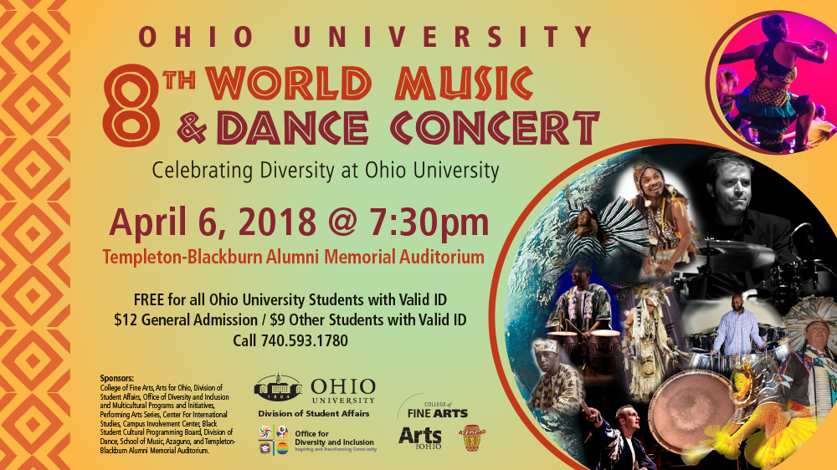

(Monroe)

## FallFest



West Virginia University annually holds a wildly popular FallFest, bringing in music artists for a vivid outdoor concert (Walker). While UAH holds a number of “Week of Welcome” events, there’s hardly a defining event that kicks off the semester. A huge outdoor concert or similarly large event could help fire up students for the semester.

Circus

(Circus)

Florida State University will be hosting a circus trip this Friday, free to all FSU students (FSU). While a circus trip may not be feasible for UAH, a circus event would be unique and interesting to attend. ACE could plan a similar daytrip. Such a trip could even be opened to the community and prospective high school students, serving to advertise the school.



These are only a few examples of the vast expanse of events explored by colleges for entertainment. Some are huge and require a lot of planning, such as West Virginia’s FallFest, while others are more laid back like the dance workshops in Ohio University’s World Music & Dance Concert. Nevertheless, each is exciting and unique – a recipe for success.

# RATIONALE FOR MORE EVENTS

Referring back to the ice cream analogy, while a variety in ice cream choices is attractive, so is a sheer multitude of choices. Giving students the power to choose from a large selection of events at different times throughout the week will allow for many proactive study breaks that ultimately boost morale and ability to focus on studies.

An article by Psychology Today states the importance of taking breaks by citing benefits such as positive health impacts, reduced fatigue, increased memory and learning, and refreshed drive (Selig). In addition to these physical and mental advantages, more events give students more opportunities to build lasting memories and friendships.

Proposing more events brings up the question: how can ACE host numerous events that are exciting and various while not being too costly? In order to host events that are cost effective, weekday events should often be smaller, saving the bigger events for weekends. This will also prove beneficial to students during the week as large events can impede students’ limited study time. There does not have to be a direct correlation between money invested in an event and its success. College students are quite proficient at entertaining themselves without much help; they just need a meeting time and common theme. For example, my experience with the Capture-the-Flag game mentioned in the introduction was a blast with the sole investments being flags and advertisements. Having a simple rally point can certainly provide loads of fun. Therefore, hosting more events should not be drastic to ACE’s budget, and improve student life.

# PROPOSTION FOR MORE EVENTS

Following examples set by other universities, ACE can host easy and inexpensive events, allowing for many more events during the semester, such as a city tour, a swing dance, or a Spikeball competition.

## City Tour

(Huntsville)

Clemson University will soon be hosting an “Atlanta-Nashville Tour,” showing students around different cities and explaining growing sectors (Atlanta-Nashville). UAH could adopt a similar concept and have a “Huntsville Exploration Day” where students ride bikes downtown, visit the Space and Rocket Center, and enjoy a local food joint. Events such as this would be particularly useful to introduce non-local students to the area, and most purchases would be in the students’ expense.

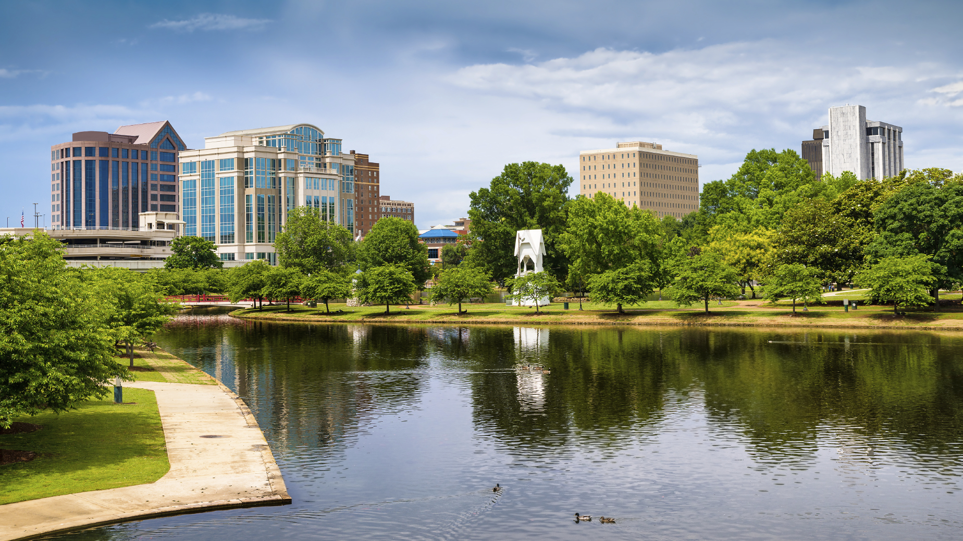

(Swing Dance)

## Swing Dance

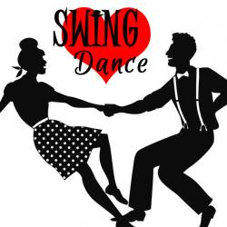

Berkeley University of California will be hosting a swing dance to live jazz music. ACE could throw a similar party. Live music is not a requirement if funds are a problem, but it would be a huge selling point. In fact, UAH already has a swing dancing club; why not collaborate with them to put a spotlight on a particular swing dance time? In this case, ACE would need not find a swing instructor or arrange music, as the swing dance club will handle all of that. ACE could then simply advertise one of the swing dances, which could attract a number of students.

## Spikeball

(Spikeball)

The University of Iowa takes the yard game Spikeball so seriously that they have intramural teams for it (Intramural). While UAH doesn’t need its own Spikeball intramural team, it’s always enjoyable to play yard games with others when taking a study break. ACE has hosted several such events in the past with success. Holding more of these types of socials should boast similar results.

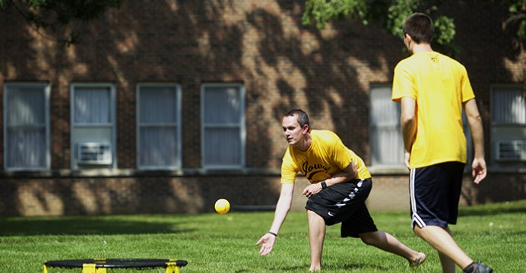

As demonstrated, there are a number of easy, cheap, and entertaining events that ACE could host. This allows for a larger quantity of social gatherings, which offers plenty of study breaks, allows for more students to meet, and makes UAH a more connected, attractive school.

# RATIONALE FOR BETTER ADVERTISEMENT

Though more events covering wider spread of interests would indeed improve the quality of campus entertainment, better advertisement would invite more participation. Why spend time and effort in setting up fun events only for a weak turn out? Low participation is detrimental to connecting students or in encouraging diversity.

According to the marketing website Target Public Marketing, “…you need new customers because without them your business will fail” (Mentis). This article continues to explain how proper advertisement can protect against the prospect of a failing business. While the article was addressed to businesses, the same advertisement principle applies to ACE. If new students are not attending, ACE may suffer in its very pursuit of event planning. For example, if event attendance is low, UAH may cut funding to ACE to use the money more appropriate to students’ interests.

Furthermore, ACE obviously has an admirable amount of graphics design talent; nearly every ACE advertisement I have seen has been an eye catcher. The problem is an ACE ad is a rare sight. If a student only hears of an event hours before it happens, he may not have set aside enough spare time to attend. The student would have an easier time planning to attend if he encountered multiple advertisements for a time leading up to the event.

# PROPOSITION FOR BETTER ADVERTISEMENT

ACE’s advertisement strategies may be easily improved with several simple adjustments such as the following: increased signage, more face-to-face interaction, and improved social media usage.

## Increased Signage

(Prominent)

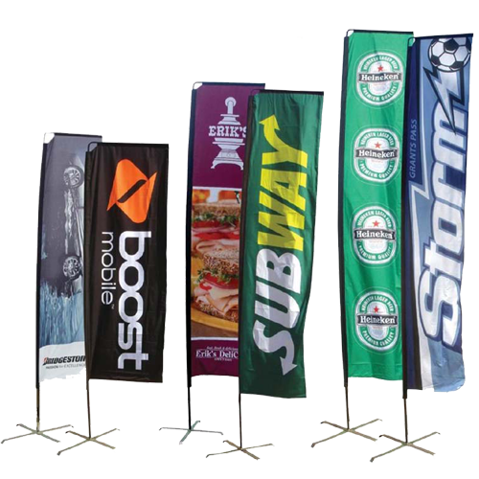

Unless intentionally searching for ACE advertisements, it is difficult to stumble across an ACE event announcement. Most of ACE’s event fliers are placed in bathrooms, bulletin boards, and few other locations on campus. The most pivotal of these locations is the bathroom “Toilet Paper,” as it is hard to miss. To improve, ACE could place signage in other key locations such as CU breezeway, Tech Hall stair way, and on the Greenway with sidewalk chalk. I feel much more informed about other campus organizations’ events thanks to their abundance of advertisements around campus.

(Handshake)

## More Face-To-Face Interaction



According to an author on Forbes, “…if brands want to build trust—the foundation for any relationship—brands need to individualize efforts, forming more personal relationships with individual consumers” (DeMers). There really is no substitute for personal interaction in advertisement. With a host of organizations and classes vying for each student’s time, ACE events would outshine the others if ACE members invited others. Also, a new student may be intimidated by the prospect of attending an ACE event unless he knows another attendee, such as an ACE member that intentionally greeted and invited him. ACE could easily implement something like the iconic UAH High 5 Friday to make their presence and events known. ACE could also have members spread the word in the CU.

## Improved Social Media Usage

(Social Media)

Personal interaction would also immensely aid ACE in their social media advertisement. With increased personal interaction, students will begin befriending ACE members on online platforms. These online connections serve to both build friendships and increase ACE advertisement. As it currently stands however, most of ACE’s online advertisements are rather ignorable. Scrolling through ACE’s Facebook page will show that many posts do not receive more than a single “like” or “share.” Instagram seems to be more helpful to ACE as it receives more feedback, but even on this platform, many advertisements receive only between twenty and thirty “likes.” ACE members connecting personally with the UAH student body can increase overall excitement on the virtual platform, boosting event awareness.



It’s clear that advertisement is pivotal to increasing event attendance. Improving advertisement will help in inviting larger groups of students to meet, further cementing UAH as a diverse and connect campus.

# RATIONALE FOR INCREASED CAMPUS UTILIZATION

Each of the last three improvement propositions can be easily implemented in using more of the campus. For example, UAH offers a variety of green spaces and buildings, allowing for a variety of events. Also, since it is UAH property, ACE would not have to pay extra cash which can permit more events. Furthermore, if students see others romping around the campus having a great time, they will want to join in: using more of the campus is easy advertisement.

# PROPOSITION FOR INCREASED CAMPUS UTILIZATION

With all of UAH’s open space, labs, gyms, tennis courts, and buildings, ACE has plenty event material to play with. There are some key locations ACE could employ to host fun events such as the CU Theater, Salmon Library’s Multimedia Lab, and green spaces around campus.

## CU Theater

(CU Theater)

The CU Theater has been a marvelous hit on the UAH campus, serving up the latest movies and comedians for free. ACE’s utilization of the CU Theater may be their strongest suit. However, I believe it could be used even more. Perhaps it could be used to display cartoons during the week, or old time TV shows at night. Whenever a student needs a study break, they can grab a group of friends and enjoy some Looney Tunes.

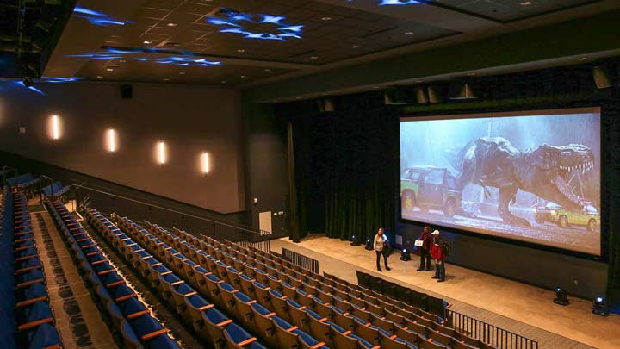

(Multimedia Lab)

## Salmon Library’s Multimedia Lab



The Library’s Multimedia Lab offers a lot of neat features and gadgets including microphones, GoPros, Photoshop, and much more (Multimedia). This is a gold mine of opportunities. ACE could hold fun events here that both stimulate the mind and offer relief from studying. After all, art “can lower your stress levels and leave you feeling mentally clear and calm” (Alban). ACE already hosts paint nights. Why not make one of those a virtual paint night?

## Green Spaces

(Water Balloon Fight)

This semester, I’ve heard multiple students wish more of the green space was used. After all, UAH is filled with numerous luscious grassy areas. Yet, they are hardly ever used. It would be fun to see Friday evening picnics, Pokemon Go adventures, lawn games, and bring-your-own-instrument jam sessions outside on sunny days. It’s fun, healthy, and inexpensive.

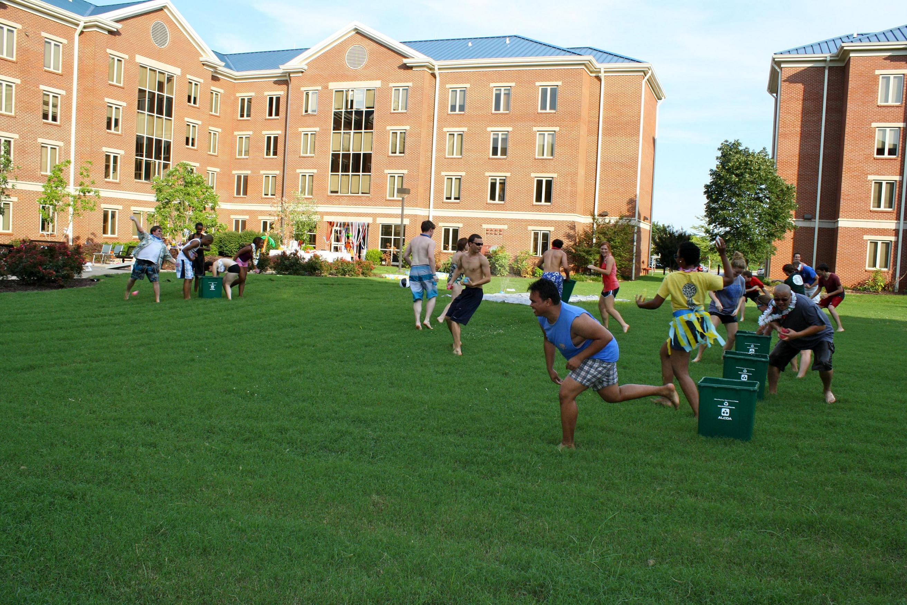

ACE events could easily skyrocket with hosting more events all around campus. Time planning could be shortened and money saved. The options listed above are only a sampling of all that can take place on our 505 acre campus. With a little imagination, even a spare grassy area can become the home of ACE’s next large tradition event.

# CONCLUSION

Many students see university as a burden they need to endure to enrich their “real lives.” However, I would argue that the college journey should be one of the chief highlights for any person. Rather than seeing college as a monotonous drudgery through waves of homework and tests, university can be a place to better one’s self, find new passions, and develop friendships.

UAH can continue to grow into this empowering environment with ACE’s help. With increased advertisement, students become more informed and welcomed to events. As ACE incorporates a wider selection of events, students will find each party unique and exciting. Also, students will have more study break options throughout the week as ACE hosts more events overall. Finally, as events are being hosted all over campus, ACE will have more event options alongside effortless advertisement.

*Let’s help create a unified and diverse student life at UAH, one event at a time.*

Works Cited

“8th World Music & Dance Concert.” College of Fine Arts, Ohio University, 21 Mar. 2018,

www.ohio.edu/finearts/dance/whats-happening/news-story.cfm?newsItem=DECE0EB1-5056-A874-1DF926C3B7E66349.

Alban, Deane. “The Mental Health Benefits of Art Are for Everyone.” Be Brain Fit,

bebrainfit.com/the-health-benefits-of-art-are-for-everyone/.

“Atlanta-Nashville Tour.” Clemson University,

calendar.clemson.edu/event/atlanta-nashville_tour#.WsLLWIjwZPY.

“Circus.” Events Calendar, Florida State University,

calendar.fsu.edu/event/fsu_night_at_the_circus_2279#.Wt0qWojwZPY.

“Critic's Choice.” Berkeley Events, Berkeley University of California,

events.berkeley.edu/.

“CU Theater.” Charger Union, The University of Alabama in Huntsville, www.uah.edu/cu.

DeMers, Jayson. “Why Modern Brand Trust Demands A Personal Relationship.” Forbes, 5 Apr.

2016, 03:51PM, www.forbes.com/sites/jaysondemers/2016/04/05/why-modern-brand-trust-demands-a-personal-relationship/#739112555c08.

FSU Information Technology Services. “FSU Circus Home Home Show

Series.” Florida State University Calendar, calendar.fsu.edu/event/fsu_night_at_the_circus_2279#.WsGwnYjwZPY.

Grove, Allen. “Choosing the Perfect College.” ThoughtCo, 2 Nov. 2017,

www.thoughtco.com/choosing-the-perfect-college-786979.

“Handshake.” Monster, Monster Worldwide, www.monster.com/career-advice/article/perfect-

your-business-handshake.

Hughes, Anthony. “12 Ways to Stop Your Employees Getting Too Bored at

Work.” CoburgBanks, 15 Aug. 2016, www.coburgbanks.co.uk/blog/staff-retention/stop-employees-getting-bored/.

“Huntsville.” Alabama Newscenter, Alabama Power, 30 Mar. 2018,

alabamanewscenter.com/2018/03/30/huntsville-area-market-average-sales-prices-up-8-percent-from-a-year-ago/.

“Intramural Spikeball Registration.” The University of Iowa,

events.uiowa.edu/event/intramural_spikeball_registration_7893#.WsLP4YjwZPY.

Knowledge@Wharton, and Cassie Mogilner. “Knowledge@Wharton.”

Knowledge@Wharton, Wharton School, 25 Mar. 2015,

knowledge.wharton.upenn.edu/article/does-variety-fuel-happiness-at-work-and-in-life-it-depends/. Accessed 2 Apr. 2018.

Mentis, George. “11 Simple Tips to Creating An Effective Ad.” Target Public Marketing, 2 Aug.

2017, www.targetpublic.com/11-simple-tips-creating-effective-ad/.

Monroe, Kyle. “FallFest.” TheDA, 12 May 2015,

www.thedaonline.com/opinion/columns/remembering-four-years-of-allfest/article_6090f7fc-f381-11e4-a415-ff6aa44addc1.html.

“Multimedia Lab.” The University of Alabama in Huntsville,

www.uah.edu/library/services/multimedia-lab.

“Ohio University 8th World Music & Dance Festival.” Ohio College of Fine Arts,

Ohio University, calendar.ohio.edu/site/finearts/event/ohio-university-8th-world-music--dance-festival-7/.

“Prominent Advertising With The Flag Banners Flagsrus New Zealand Marketing Flags And

Banners.” Wally Designs, www.wallofwally.com/marketing-flags-and-banners/outdoor-flag-banner-displays-for-sale-marketing-flags-and-banners/.

Selig, Meg. “How Do Work Breaks Help Your Brain? 5 Surprising

Answers.” Psychology Today, Sussex Publishers, 18 Apr. 2017, www.psychologytoday.com/us/blog/changepower/201704/how-do-work-breaks-help-your-brain-5-surprising-answers.

“Social Media.” The World University Rankings, www.timeshighereducation.com/blog/why-

academics-should-not-make-time-social-media.

“Spikeball.” The Daily Iowan, 4 Sept. 2015, daily-iowan.com/2015/09/04/spikeball-piques-ui-

interest/.

“Swing Dance.” 7th Annual YHS Band Valentine's Day Swing Dance, Town of Yorktown,

www.yorktownny.org/community/7th-annual-yhs-band-valentines-day-swing-dance.

Walker, Chelsea. “Remembering Four Years of FallFest.” The Daily Athenaeum, 12

May 2015, www.thedaonline.com/opinion/columns/remembering-four-years-of-fallfest/article_6090f7fc-f381-11e4-a415-ff6aa44addc1.html.

“Water Balloon Fight.” First and Second Year Housing Requirement Information, The University

of Alabama in Huntsville, www.uah.edu/housing/prospective-residents/requirement/first-and-second-year-housing-requirement-2.